Manuela Teixeira – Profile

Agrupamento de Escolas Dr. Alberto Iria

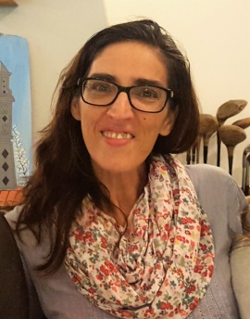Maria Manuela Teixeira, BA in Portuguese and English Teaching by the University Nova of Lisbon, she is a teacher since 1994. She teaches both English and Portuguese to students of the 3rd cycle of basic education (ages 12/16) and CEF (Educational and Vocational training Courses). The Alternative Curricula Courses (students, aged 14 or younger, with learning problems are integrated in alternative curricula classes.

In 2013/14 she was a KEY for Schools Examiner and General Marker. In 2014/2015 she was a PET for Schools Examiner and General Marker.

She has participated in an *Etwinning Project*, ”*Day of the Languages-Skype/Video/Postcards ”*.

She currently participates in an *Etwinning Project*, developed in partnership with a Spanish teacher, *“The Image of the Other”*, that involves 8 teachers and 258 students from five countries (Italy, Slovakia, Poland, Spain and Portugal).