Four technology mediated language tasks. A Portuguese experience

Isabel Orega
Universidade do Algarve
Faro-Portugal
miorega@ualg.pt

Lúcia Nassa Tardão
Agrupamento de Escolas Dr. Alberto Iria
Olhão – Portugal
lucia.tardao@gmail.com

Abstract
This paper presents the contribution of the Portuguese participants in the PETALL project which is dedicated to technology mediated task-based language learning. PETALL is a Life Long Learning project funded by the European Commission. Participants from 10 countries work in tandems involving a university or a teacher training institution and a secondary or basic school. The project is coordinated by the University of Algarve, in Portugal. Task-based language learning has a central role within the principles of language learning and teaching nowadays. ICT adds extra potential to the tasks and makes them very motivating and appealing to the students.
The main purpose of the project is to design language tasks that “travel well” which means that the tasks are adequate to several language teaching and cultural contexts. The project design implies that each tandem works with two neighbouring tandems. In this way, we have been working with the Spanish and Scottish participants. The paper presentation introduces the four language tasks that have been used with 9th grade students at Escola Alberto Iria in Olhão, in the south of Portugal. We explain the rationale and process of implementing the tasks, as well as students’ feedback and evaluation.

- Introduction

The value of task-based language learning (TBLT) has been thoroughly discussed by academics, the Common European Framework of Reference for Languages (CEFR) and national curriculum language Programmes such as the Portuguese impel and advise their use as methodological asset. The importance of technologies in our life is evident to the modern world. Everyone is motivated to use a computer, a mobile phone, a camera or any digital gadget. Technologies enable people to do things better and faster. It is therefore mandatory that ICT integrate the learning and teaching circle and become a fulcrum within any classroom. The question is: How to integrate them in the L2 lesson plan/classroom?
The PETALL project purpose is to encourage the use of ICT-based tasks in the language classroom. PETALL stands for Pan European Task Activities for Language Learning. The project seeks to provide examples of good practices in technology-mediated TLBLT that can be easily used in different languages and educational contexts.
The consortium is composed of 10 tandems, each tandem formed by a teacher training department and a junior or senior high school.
PETALL aims to explore: the dynamics of transnational collaborative work between teachers in task design and management; the way evaluation tools can leverage both the quality of teacher education in technology-mediated TBLT and the effectiveness of task-based language learning; the aspects that guarantee that the tasks proposed by the project travel well.

1.1. The Procedure

Each tandem designed 4 tasks for two neighbouring countries. The tasks were tried out by pupils in the practice schools of the own tandem and of those of the other tandems so as to assure that they “travel well”. They were evaluated by end-users and will be evaluated by independent experts.
.
The products will be translated into all the languages of the consortium.

1.2 The Tasks

The Portuguese tandem had to produce 4 tasks for 2 neighbouring countries and had to implement four tasks using ICT in their production, two tasks from/to Spain and two tasks from/to Scotland. These tasks were to be performed and assessed by students. Formats for the tasks were produced by the consortium of countries, as to unify the proceedings. All the templates will be available at the consortium website: http://petallproject.wix.com/petall.

The Spanish tasks

NGO’s a better world is possible

The task: a PowerPoint presentation about a NGO located in their city.

In this task students followed the proceedings in a webquest.

Each student had a different role within a group. He or she should become an expert on:
- ORGANIZATION
- PROBLEMS
- PROJECTS
- VOLUNTEER WORK
They had to search for information on the web and be prepared to answer questions on the topic of their expertise.

Students got together to share and analyse the information found on the websites or collected at the NGO. Each group member presented the information they gathered on their role.
The task was implemented in a computer room where each group of 4 students had to share a computer. The first difficulty for the implementation of the task was having every student at work at the same time. Despite the technical difficulties, the students found it easy to understand the task and were able to perform it. Nearly 87% of the students evaluated the task satisfactorily.
Once Upon a Time
The task: Write a 6-page story by using slides as hints and “Storybird” platform (https://storybird.com/), based on the theme “Violence in our World”, using randomly-chosen pictures.

The main problem in implementing the task was related to the difficulty the students had in writing the story maintaining to the art and theme chosen. When using the digital platform “Storybird”, if we choose a specific art (group of images) we have to keep within that art and cannot use images from another art, this makes it difficult to respect the theme. A possible solution is to eliminate the theme “Violence in our world” and keep the task as it is but without the obligation of responding to that theme. Another possible way of using the task keeping the theme is to ask each group of students to write a six pages book using whatever art they like as long as they keep to theme “Violence in our World”. In this way, students wouldn’t depend on other students, outside their group, to choose a picture. The idea of this chain work was to develop collaborative work within the class, but, unfortunately students weren’t able to cope with this and to “unblock” student’s creativity the teacher was forced to admit that groups could change their pictures if they found it difficult to express their ideas using the pictures chosen by their colleagues. Discussion was arisen about what to write next and even weaker students contributed with their ideas.
Another hint to make the task feasible was to “Print Screen” the pictures to word processor so that students could work using the pictures even in the absence of internet connection.
The task required 1 lesson to explore the “Storybird” platform, to sign in and explain the task, 2 lessons to produce the books and 1 lesson to present the outcomes.
When presenting the outcome, each student read a page of the group’s book and in the end the group’s leader explained what the idea behind the story was. Meanwhile the other groups filled in the evaluation grids.
Students found the task interesting and admitted they had enjoyed using “Storybird” which they saw as an asset for future text writing, even in their own language.
Almost 80% of the students rated the task in levels 3 and 4 of satisfaction. 1 corresponds to the lowest level of satisfaction and 4 to the highest.
“The Best job in the World”
Scottish Task/Portuguese Implementation

The task was: To apply for a job using a video application.
Students watched the video https://www.youtube.com/watch?v=GcCXPO68_CU and answered questions about it:
- What is Ben Southall’s job?
- What job vacancies are there available?
- What is the contract pay?
- What qualifications or skills do people need for these jobs?
- What are the responsibilities for each of these jobs?
- What job would you apply for? Why?
Next, they worked in pairs, chose individually the job they would like to apply and wrote an outline of their videos. They searched the internet for the qualifications and skills required to perform the job they wanted to apply.
Students wrote their video’s scripts mentioning:
- Personal Identification: name; date and place of birth; personal qualities, marital status;
- Qualifications: University degree, languages spoken; other qualifications (driving licence; ICT qualifications; etc);
- Reasons for applying for the job.

As a homework assignment, the teacher asked the students to film their application videos. Weaker students were told they could read their application.

Lesson # 2:
At the computer room students worked in small groups to edit their videos.
The videos were watched and each pair of students assessed and evaluated their partners’ videos, using the table below:

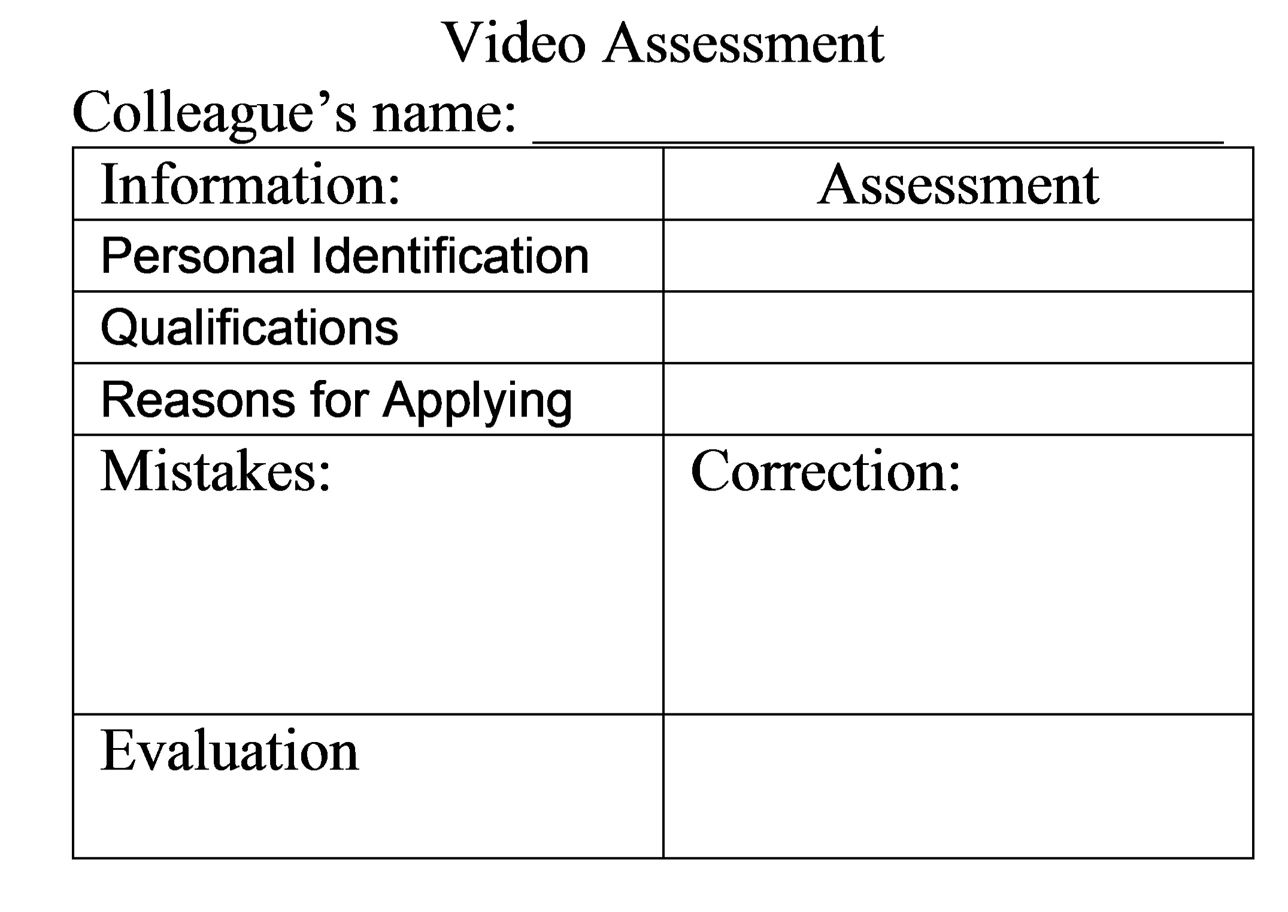
Figure 1 – Video assessment grid

Almost 95% of the students rated the task very satisfactorily (level 3 or 4 of satisfaction) which reflects the success of the task. The students performed to their level A2/B1 and the mistakes where not impeditive of understanding.
Nevertheless there are some aspects that can be predicted within the format of the Beta version of the task.
“Documentary about your school”
Scottish Task/Portuguese Implementation
Lesson # 1
The groups were asked to draw an outline for a school documentary about their school which could be uploaded on Facebook or youtube or even on the school’s internet page. They were asked to focus on the school’s facilities and they were told they could include interviews to other students or teachers.
The students discussed in groups what they were going to include in their video, what video editor they could use and they divided roles: Speakers, cameraman, editors. The teacher explained they could use the following sites/programmes to help them with the task:

Video editors | - Windows movie maker;  - www.wevideo.com ;  - www.magisto.com;  - www.youtube.com/editor
Voice generators | - www.fromtexttospeech.com  - www.text-to-speech.imtranslator.net/
Language tools | - www.linguee.com  - www.googletranslator.com

These tools allowed students to write their texts, edit their videos and use online voice generators to use in their video.
Lesson #2
The students got together in groups. They discussed the outline, the programmes they could use to edit the video and wrote down the script. The teacher corrected the scripts and asked students to film their videos after classes.

Lesson #3

Assessment
The videos were watched and assessed by students and teacher. The mistakes were corrected and the teacher explained what should be corrected. Although there were translation, collocation and grammar structures, these were not impeditive of understanding the content and were absolutely expectable for the students level of proficiency.
71,1% of the students rated the task very satisfactorily (level 3 or 4 of satisfaction) which reflects the success of the task.

2.Conclusion

González-Lloret & Ortega (2014) summarizing the opinion of several authors identify five features of tasks in the context of techonology-and-task-integration: Primary focus on meaning, goal orientation, learner-centeredness, holism, and reflective learning. We may say that the choice and implementation of our four tasks exemplify these five principles, although we would like to emphasize some of these features:
- They prepare students for real-life language skills;
- All the four skills can be used within the targeted level;
- They prepare students to communicate effectively in a real – life context;
- They travel well since they focus on basic human needs;
- Using authentic material stimulates students to understand the practicality of what they are performing;
- They match students’ experiences and interests and enable them to use ICT in a variety of ways (Video, mobile phones, video software, online language tools);
- A large number of functions, notions and communicative tasks were used.
Furthermore, the learner-centeredness is also a strong feature of the tasks presented. Although they were suggested by the teacher, the process of completing them was based on the students’ decisions and choices, while the teacher functioned only as a consultant when necessary. Finally, the authenticity of the tasks involves an integration of form-function-meaning which contribute to their holistic nature.

References

Ellis, R. (2003). Task-based language learning and teaching. Oxford: Oxford University Press.
González-Lloret, M. & Ortega, L (2014) Towards technology-mediated TBLT: An introduction. In M. González-Lloret & L. Ortega (Eds) Technology-mediated TBLT Researching Technology and tasks. (pp. 1-22). Amsterdam, John Benjamins Publishing Company.
Nunan, D. (2004). Task-based language teaching. Cambridge: Cambridge University Press. doi:10.1017/CBO9780511667336
Thomas, M., & Reinders, H. (Eds). (2010). Task-based language learning and teaching with technology. New York: Continuum.

