**PETALL**

**[*Name of Institution*]**

Task Evaluation Questionnaire

**[*Date*]**

**[*Title of task*]**

Please tick the smiley face that matches your opinion:

1. This activity taught me a lot of things/few things

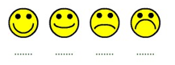

A lot of things Few things

1. The activity was easy/difficult



Easy Difficult

1. I had a lot of fun/no fun



A lot of fun No fun

1. The activity helped me to improve my **[specify language]**



A lot Very little

1. I learned how to use technological resources to communicate and/or express my ideas



A lot Very little